Day 5:

Creating Simple-Rest-API using express JS . response in different format.

Rest API http method
let employees = [
{eid:100,ename:John”,salary:12000},
{eid:101,ename:Charlie”,salary:10000}
]
- Get methods : get all employee details in json format.
- Get methods : search particular employee details using id, name, salary with query param or path param.
- Post method : to store the employee information in array or in database ie mysql or mongodb etc.
- Put method : it is use to update the existing employee records using id property. Update salary, name using id property.
- Patch method : it is also update to update existing employee records.
Patch mainly use to update partial object like update salary or name using id. Using put we need to update all property of existing objects.
- Delete method : to delete particular object information using particular property like id.

To test these rest api we need rest api plugin.
- Post man

Create the folder as rest-api-for-employee
npm init -y
npm install express

open this folder in VS Code

testing post method using post man

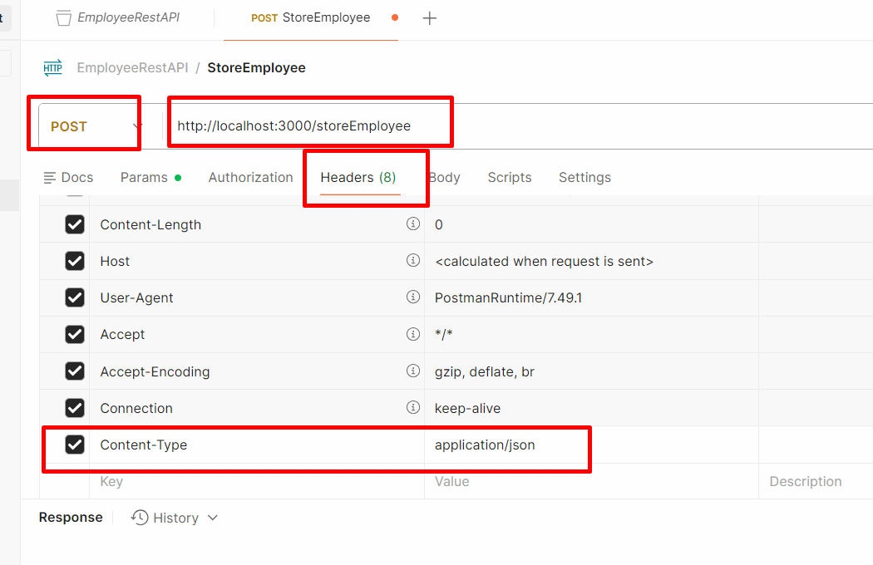

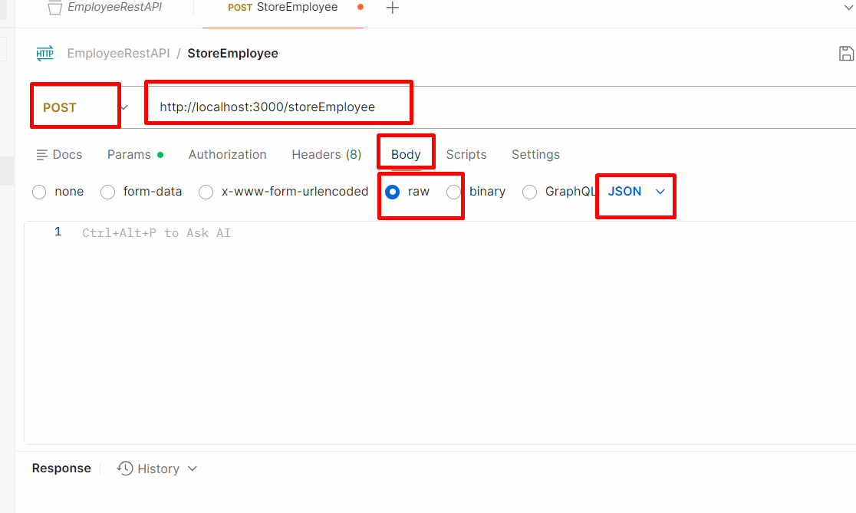

Connecting mongo db database using express or node js program

Using mongo db module
Mongo db is one of the external node js module which help to connect mongo db database using native API style.

